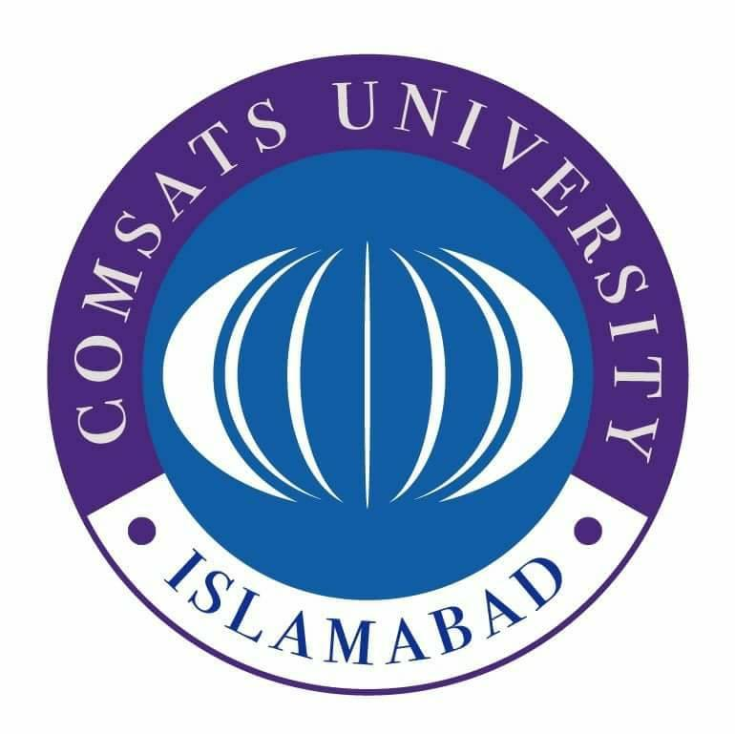

**COMSATS University Islamabad Attock Campus**

**Department of Computer Science**

**Lab Terminal**

**Course Title: Compiler Construction**

**Course Code: CSC441**

**Submitted To:**

**Sir. Bilal Bukhari**

**Submitted by:**

**Sami Ullah**

**Reg No:** **CIIT/FA21-BCS-041/ATK**

**Date of Submission: January 1, 2025**